August 7, 2018
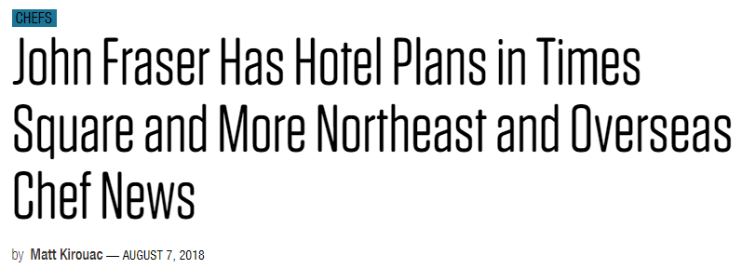

http://plateonline.com/chefs/move/john-fraser-has-hotel-plans-times-square-and-more-northeast-and-overseas-chef-news

